Catalog
Software Research
1. Multiple Choice
2. True or False Questions
3. Fill-in the blanks
4. Short answer Questions
Symbolic AI
1. Multiple Choice
2. True or False// Questions
3. Fill-in the blanks
4. Short answer Questions
Software research
- Multiple Choice
1. What is a data structure?
A. A step-by-step recipe for solving problems
B. A way data is stored so it can be used efficiently later
C. A runtime environment for programs
D. A network protocol for sending data

2. Which sorting algorithm repeatedly compares adjacent elements and swaps them if out of order?
A. Quick Sort
B. Merge Sort
C. Bubble Sort
D. Heap Sort
3. What is the average (typical) time complexity for Quick Sort?
A. O(n)
B. O(n log n)
C. O(n²)
D. O(log n)
4. Which statement about Bubble Sort is true?
A. It is in-place and usually has O(1) space complexity.
B. It always outperforms Quick Sort on large datasets.
C. It uses extra arrays equal to input size.
D. It guarantees O(n log n) time.
5. Which protocol provides reliable, ordered delivery and uses a three-way handshake?
A. UDP
B. HTTP
C. TCP
D. ICMP
6. Which OSI layer is primarily responsible for routing packets using IP addresses?
A. Application
B. Transport
C. Network
D. Data Link
7. What does a VPN mainly provide for your internet traffic?
A. Faster raw download speed always
B. Encryption and IP masking through a VPN server
C. Permanent removal of malware from a device
D. Replaces TCP with UDP
8. Which vulnerability injects malicious JavaScript into web pages so it runs inside users’ browsers?
A. CSRF
B. SQL Injection
C. XSS (Cross-Site Scripting)
D. Buffer overflow
9. UI vs UX: which is correct?
A. UI = user’s emotional journey; UX = visual buttons and menus
B. UI = visual and interactive elements; UX = overall user experience
C. UI and UX are identical terms with no difference
D. UX = only the code behind a website
10. Which technology (approximate year) helped make web pages more dynamic by allowing scripts in browsers?
A. JavaScript — 1995
B. AJAX — 1970
C. PHP — 2010
D. CSS — 1984
11. The “aesthetic-usability effect” means:
A. Attractive interfaces are perceived as easier to use.
B. Ugly interfaces are always more usable.
C. Usability has nothing to do with aesthetics.
D. Aesthetics only matter for print, not web.
12. Which design choice helped Robinhood attract many novice investors?
A. Complex advanced-charting by default
B. High fees and minimum balances
C. Minimalist interface and commission-free trades
D. Removing mobile support
13. Which of these is a correct definition of a database?
A. A program that only runs on smartphones
B. A collection of related data stored electronically for easy access and modification
C. A network protocol for communication between servers
D. A programming language for front-end UI
14. What does DBMS stand for and what is one of its components?
A. Data Binary Management System — GPU
B. Database Management System — Master File Table (MFT) is a DBMS software feature
C. Distributed Backup & Mail Service — Browser
D. Database Management System — Components include Hardware, Software, Data, Users, Procedures
15. Which operation is NOT part of CRUD?
A. Create
B. Read
C. Update
D. Encrypt
16. Which statement correctly contrasts SQL and NoSQL?
A. SQL is schema-less; NoSQL always uses fixed tables.
B. SQL stores data in structured tables; NoSQL often stores unstructured or flexible documents.
C. SQL cannot be used by banks or schools.
D. NoSQL is always better than SQL in every case.
17. What is the kernel?
A. A GUI toolkit for apps
B. The core part of the OS that manages resources like CPU and memory
C. A type of file system used only by macOS
D. A virtualization hypervisor type
18. Which of these is an example of a Type-1 (bare-metal) hypervisor?
A. VirtualBox
B. VMware ESXi
C. Windows Explorer
D. Chrome
19. Which file system is commonly used on Linux servers?
A. NTFS
B. APFS
C. ext4
D. FAT12
20. AWS launched S3 and EC2 in:
A. 1995
B. 2006
C. 2015
D. 2023
21. Which of these is NOT a common sorting algorithm mentioned in the notes?
A. Bubble Sort
B. Quick Sort
C. Selection Sort
D. Radix Sort
22. What does the “I” stand for in the OSI model?
A. Internet
B. Interconnection
C. Interface
D. Infrastructure
23. Which Big-O class grows faster than O(n²) but slower than O(2ⁿ)?
A. O(n!)
B. O(n log n)
C. O(log n)
D. O(n)
24. Which protocol is preferred for live Zoom video because speed beats perfect delivery?
A. TCP
B. UDP
C. HTTP
D. ICMP
25. In the notes, which layer adds MAC addresses to frames?
A. Physical
B. Data Link
C. Network
D. Transport
26. What tool is mainly used to see live network packets on your own machine?
A. Firewall
B. Wireshark
C. VPN
D. Antivirus
27. Which of these is a NoSQL category listed in the notes?
A. Graph database
B. Spreadsheet database
C. Hierarchical database
D. Network database
28. What is the first step in the CRUD cycle?
A. Read
B. Create
C. Update
D. Delete
29. Which Linux filesystem is the default on most servers today?
A. FAT32
B. NTFS
C. ext4
D. HFS+
30. A Type-2 hypervisor runs on top of what?
A. Bare metal
B. Another hypervisor
C. A host operating system
D. The cloud only

- True or false questions (highlight the correct answer)

1. T/F — An algorithm’s Big-O notation describes performance as input size approaches infinity.
2. T/F — Selection Sort finds the smallest element and swaps it into the next sorted position.
3. T/F — Space complexity measures how much time an algorithm takes to run.
4. T/F — Sorting algorithm adaptiveness refers to how well it performs on partially-sorted data.
5. T/F — UDP prioritizes speed over guaranteed delivery.
6. T/F — A firewall can block incoming traffic based on rules (IP/port).
7. T/F — SQL Injection targets the browser’s DOM rather than the server’s database.
8. T/F — A Web Application Firewall (WAF) can help block common SQLi and XSS patterns.
9. T/F — First impressions of a website often form within milliseconds.
10. T/F — Duolingo’s streaks are an example of a behavioral design intended to increase retention.
11. T/F — Color choices can influence perceived trust and emotion in UI design.
12. T/F — A major redesign that breaks established mental models can quickly frustrate users.
13. T/F — MongoDB is an example of a NoSQL document database.
14. T/F — CRUD stands for Create, Read, Update, Delete.
15. T/F — NoSQL databases are typically more rigid about schema than SQL databases.
16. T/F — One of the purposes of databases is to reduce duplicated data and inconsistency versus flat-file systems.
17. T/F — Every running process is assigned a unique Process ID (PID).
18. T/F — Virtual machines are often stored as disk image files that hypervisors can load.
19. T/F — Contiguous file allocation can lead to fragmentation over time.
20. T/F — CPU scheduling and time-sharing make multiple programs appear to run simultaneously on the same core.
21. T / F – Bubble Sort stops early if no swaps occur in a pass (adaptive).
22. T / F – O(n log n) is generally faster than O(n²) for large inputs.
23. T / F – The Network layer of the OSI model uses port numbers to route data.
24. T / F – A VPN can hide your real IP address from the websites you visit.
25. T / F – Stored XSS saves malicious code on the server itself.
26. T / F – MongoDB stores data in rows and columns like Excel.
27. T / F – The kernel is loaded into RAM during the boot process.
28. T / F – VirtualBox is an example of a Type-1 hypervisor.
29. T / F – NTFS supports file permissions and journaling.
30. T / F – AWS EC2 lets you rent virtual computers by the minute.

- Fill in the blanks
1. ________ Sort repeatedly compares adjacent elements and swaps them when they are out of order.
2. Big-O notation describes how an algorithm’s ________ or ________ grows as input size increases.
3. The OSI model has ________ layers.
4. A VPN masks your real ________ by routing traffic through a VPN server.
5. XSS stands for ________ ________ ________.
6. SQL is an acronym for ________ ________ ________.
7. CRUD stands for Create, ________, Update, Delete.
8. During boot, the OS loads the ________ into memory.
9. A Type-1 hypervisor runs directly on the physical ________.
10. The Linux filesystem commonly used on servers is called ________.
11. The notation O(____) describes an algorithm that doubles work when input grows by one.
12. The ____ layer of TCP/IP combines Application, Presentation and Session from OSI.
13. A ____ handshake starts a TCP connection.
14. ____ is the AWS service for renting file-storage in the cloud.
15. The ____ worm used stored XSS to add “but most of all, Samy is my hero” to MySpace profiles.
16. In NoSQL, a ____ database stores entities as nodes and relationships as edges.
17. The Master File Table (MFT) is used by the ____ file system on Windows.
18. ____ allocation keeps an index of all blocks a file occupies (NTFS method).
19. A virtual machine is often stored as a ____ image file that a hypervisor can load.
20. ____ is Amazon’s brand name for its cloud-computing division.

- Short Answer
1. Time complexity tells us how the running time changes when the input gets bigger. Look at this simple Python function that searches an ordered list by cutting the search range in half each step:
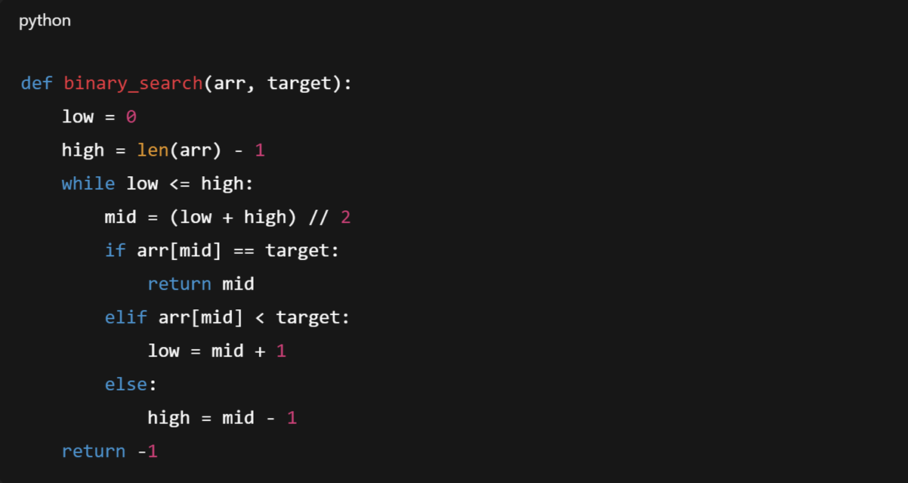
In one short sentence, what is the time complexity of this function in Big-O notation? Why?
2. TCP stands for Transmission Control Protocol. It makes sure data arrives and is in order. In one short sentence, what is UDP and when might we use it instead of TCP?
3. People often confuse UI and UX — they’re related but different. In one or two sentences, explain the difference between UI and UX, and give one tiny example (like a button or login flow).
4. Databases let programs store and retrieve data. CRUD lists the four basic actions. What does CRUD stand for? Write one simple example SQL command that shows the Create operation.
5. Virtualization lets one physical computer run many virtual ones. In one or two sentences, what is virtualization, and what’s the main difference between a Type-1 and Type-2 hypervisor?
6. You see an algorithm with nested loops: outer runs n times, inner runs n times for every outer step.
a) Write its time-complexity in Big-O notation.
b) Explain how the process works!
7. Give one advantage and one disadvantage of running software on AWS EC2 instead of your own desktop PC.

- Answer Key Multiple Choice
1. B
2. C
3. B
4. A
5. C
6. C
7. B
8. C
9. B
10. A
11. A
12. C
13. B
14. D
15. D
16. B
17. B
18. B
19. C
20. B
21. D
22. B
23. A
24. B
25. B
26. B
27. A
28. B
29. C
30. C
- Answer Key True or False
1. True
2. True
3. False
4. True
5. True
6. True
7. False
8. True
9. True
10. True
11. True
12. True
13. True
14. True
15. False
16. True
17. True
18. True
19. True
20. True
21. True
22. True
23. False
24. True
25. True
26. False
27. True
28. False
29. True
30. True

- Answer Key Fill in The Blanks
1. Bubble
2. time / space (either or both; acceptable: “time” or “space” or “time and space”)
3. 7
4. IP address
5. Cross-Site Scripting
6. Structured Query Language
7. Read
8. kernel
9. Hardware
10. Ext4
11. 2^n
12. Application
13. three-way (or 3-way)
14. S3
15. Samy
16. graph
17. NTFS
18. Indexed
19. disk (or VM / virtual-disk)
20. AWS

- Answer Key Short Answer
1. O(log n) — because the function halves the search range each step, so the number of steps grows logarithmically with input size.
2. UDP (User Datagram Protocol) is a faster, connectionless protocol that does not guarantee delivery or order — used for things like live video or online games where speed matters more than perfect delivery.
3. UI (User Interface) is the visible parts — buttons, colors, layout. UX (User Experience) is the whole experience — how easily someone can finish a task. Example: a big clear “Buy” button is UI; the whole checkout process that makes buying quick and painless is UX.
4. CRUD = Create, Read, Update, Delete. Example Create command: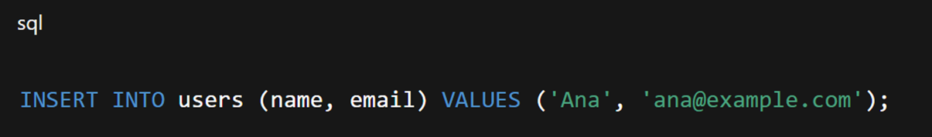
5. Virtualization runs several virtual machines on one physical host. Type-1 hypervisors run directly on the hardware (faster, used in data centers); Type-2 hypervisors run on top of an existing OS (easier for desktop testing).
6. a) O(n²)
b) Because the inner loop runs n times for each of the n outer iterations, resulting in n × n total steps.
7. Advantage: instant global scale / no hardware upkeep. Disadvantage: ongoing cost & internet-dependency (if connection drops, access is lost).

Symbolic AI
Multiple Choice Questions:
- What is another name for Symbolic AI?
A. Deep Learning AI
B. Probabilistic AI
C. Reinforcement AI
D. Good Old-Fashioned AI (GOFAI)
- Which component of a Symbolic AI system stores facts and rules?
A. User Interface
B. Inference Engine
C. Knowledge Base
D. Neural Network
- Which reasoning method moves from general rules to specific conclusions?
A. Deductive
B. Inductive
C. Abductive
D. Heuristic
- Which of the following is a well-known medical expert system based on Symbolic AI?
A. Watson Health
B. DeepMind
C. MYCIN
D. AlphaFold
- What does the STRIPS system use to define actions in robotic planning?
A. Reward functions
B. Preconditions, Add list, Delete list
C. Neural weights
D. Probability distributions
- Which of the following best describes a key strength of Symbolic AI?
A. Provides transparent and explainable reasoning
B. Learns from unlabeled data
C. Handles noisy data well
D. Automatically scales with big data
- Why is Symbolic AI considered “brittle”?
A. It requires too much computing power
B. It fails when inputs fall outside its predefined rules
C. It cannot process text
D. It uses probabilistic logic
- Which paradigm uses hand-coded rules and logical inference?
A. Connectionist AI
B. Behaviorist AI
C. Symbolic AI
D. Evolutionary AI
- In NLP, what does a parse tree help Symbolic AI determine?
A. Word frequency
B. Language translation accuracy
C. Sentiment polarity
D. Grammatical structure and semantic roles
- Which inference strategy starts from known facts to reach conclusions?
A. Forward chaining
B. Backward chaining
C. Deep learning
D. Monte Carlo simulation
- What is a major limitation of Symbolic AI in handling real-world data?
A. It requires GPU acceleration
B. It cannot process structured data
C. It struggles with ambiguity and uncertainty
D. It overfits easily
- Which system allowed geologists to query a database using English questions? A. DENDRAL
B. ELIZA
C. Cyc
D. LUNAR
- What logical framework is commonly used in Symbolic AI knowledge representation?
A. Bayesian networks
B. First-order logic
C. Convolutional layers
D. Markov decision processes
- Which of the following is NOT a typical application of Symbolic AI?
A. Medical diagnosis
B. Fraud detection
C. Image recognition from raw pixels
D. Legal reasoning
- What does the Physical Symbol System Hypothesis propose?
A. Intelligence emerges from neural connections
B. Intelligence requires embodiment
C. Intelligence arises from symbol manipulation
D. Intelligence is probabilistic by nature
- Which AI paradigm is best suited for domains requiring auditability and justification?
A. Deep learning
B. Symbolic AI
C. Reinforcement learning
D. Generative adversarial networks
- What is a key challenge in scaling Symbolic AI systems?
A. Exponential growth in rules and symbols
B. Lack of labeled data
C. Slow GPU performance
D. Poor natural language understanding
- Which reasoning type is more common in machine learning than in classical Symbolic AI?
A. Deductive
B. Modal
C. Syllogistic
D. Inductive
- What is a hybrid approach that combines neural networks with symbolic reasoning called?
A. Fuzzy logic AI
B. Neuro-symbolic AI
C. Bayesian symbolic AI
D. Cognitive architecture
- Which video game uses symbolic rules to govern character behavior (e.g., “IF Energy < 20 THEN Sleep”)?
A. Minecraft
B. Fortnite
C. The Sims
D. Tetris

True or False Questions:

- Symbolic AI relies on large datasets for training like deep learning models.
- MYCIN used approximately 600 hand-coded rules for medical diagnosis.
- Symbolic AI can naturally handle probabilistic statements like “60% chance of rain.”
- Deductive reasoning guarantees a true conclusion if the premises are true.
- The inference engine in Symbolic AI applies logical rules to the knowledge base.
- Symbolic AI systems learn autonomously from experience without human input.
- STRIPS is an example of a symbolic planning system used in robotics.
- Commonsense reasoning is easy to implement in Symbolic AI because everyday knowledge is simple to encode.
- Symbolic AI is often described as a “black box” due to its opaque decision-making.
- Inductive reasoning in Symbolic AI leads to certain conclusions.
- The LUNAR system translated English questions into logical database queries.
- Symbolic AI performs well on unstructured data like images and audio.
- Forward chaining begins with a goal and works backward to verify facts.
- Symbolic AI dominated AI research from the 1950s to the 1980s.
- The General Problem Solver (GPS) was one of the first symbolic AI programs.
- Symbolic AI cannot represent relationships between concepts using structured data.
- Neuro-symbolic AI aims to combine the transparency of symbolic systems with the adaptability of neural networks.
- A typo like “feavr” would likely be understood by a Symbolic AI system as “fever.”
- In Symbolic AI, knowledge is often represented as a semantic network or logical graph.
- ChatGPT is a pure example of Symbolic AI with no statistical components.

Fill-in-the-Blank Questions:

- Symbolic AI is also known as ______________________ (GOFAI).
- The two core components of a Symbolic AI system are the ______________________ and the ______________________.
- In robotic planning, the ______________________ system defines actions using preconditions, an add list, and a delete list.
- ______________________ reasoning moves from general rules to specific conclusions and guarantees a true outcome if the premises are true.
- The medical expert system ______________________ used around 600 hand-coded rules to recommend antibiotics for bacterial infections.
- Symbolic AI struggles with real-world ambiguity because it cannot natively handle ______________________ or incomplete information.
- In NLP, a ______________________ is built to represent the grammatical structure of a sentence like “The cat chased the mouse.”
- The ______________________ hypothesis states that a physical symbol system has the necessary and sufficient means for general intelligent action.
- Unlike neural networks, Symbolic AI provides ______________________ reasoning, meaning every step of its decision process can be traced and explained.
- The natural language interface ______________________ allowed geologists to query a database using plain English questions about moon rock samples.

Short Answer Questions:

- What are the two main components of a Symbolic AI system?
- Name one real-world application of Symbolic AI in medicine.
- What is the main job of the inference engine in Symbolic AI?
- Why is Symbolic AI considered transparent?
- What does STRIPS use to define an action in robotic planning?

Answer Key Multiple Choice Questions:
- D
- C
- A
- C
- B
- A
- B
- C
- D
- A
- C
- D
- B
- C
- C
- B
- A
- D
- B
- B
Answer Key True or False:
- False
- True
- False
- True
- True
- False
- True
- False
- False
- False
- True
- False
- False
- True
- True
- False
- True
- False
- True
- False
Answer Key Fill-in-the-Blank Questions:
- Good Old-Fashioned AI
- Knowledge base, Inference Engine
- STRIPS
- Deductive
- MYCIN
- Uncertainty
- Parse Tree
- Physical Symbol System
- Transparent (or interpretable / explainable)
- Lunar
Answer Key Short Answer Questions:
- Knowledge Base and Inference Engine
- MYCIN
- To apply logical rules to the knowledge base to draw conclusions.
- Because its decisions are based on clear, traceable rules and logic.
- Preconditions, an Add list, and a Delete list

